**University of the Western Cape Library**

**Seminar Programme**

**Topic:** After Olympics Unlock Olympic Knowledge

**Time:** 09h00 – 13h00

**Date:** 31st October 2024

**Venue:** Library Atrium

**About the Seminar**

The theme “After Olympics Unlock Olympic Knowledge” forces the stakeholders who form part of a sports program to reflect and make open access sources available to those athletes who need it most. The objectives are to analyze performance data, promote knowledge exchange, highlight innovation in sports science and technology and to educate on the legacy and impact of Olympic Games.

This seminar will introduce the audience to various expert perspectives on the theme “After Olympics Unlock Olympic Knowledge”.

**About the Speakers**

**Professor Marion Keim: UNESCO Chair for Sport and Peace in Africa**

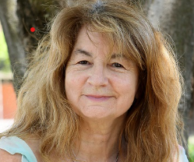

Prof. Marion Keim is the UNESCO Chair of Sport, Development and Peace and Olympic Education at UWC, she chairs the Foundation for Sport, Development and Peace and the Pierre de Coubertin Committee of South Africa. Marion served on the Eminent Persons Group for Sport and Transformation 2012-2023 and the SASCOC Education and Training Commission 2017-2021. She is an Advocate of the High Court, an IOC Commissioner for Culture and Olympic Education and the Secretary-General of the Association of National Pierre de Coubertin Committees of Africa. Prof. Marion Keim is the Director of Olympic Studies and Research Action Group, UWC. She is an established rated researcher (NRF) and locally and globally recognised for conducting multidisciplinary research and lecturing in Sport and Development and focuses on sport policy, youth leadership, social transformation, peace and sport for social change and inclusion.

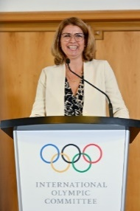

Ms Maria Bogner has been working for the International Olympic Committee since 16 years and since 14 years leads the IOC’s Olympic Studies Centre, which has the mission to make Olympic knowledge accessible to all and to foster Olympic Education and Research, which is also the topic she will present to us today. Through its various teams services and programmes the IOC Olympic Studies Centre serves the Olympic Movement stakeholders as centre of reference for Olympic knowledge and in particular supports scholarly research on the Olympic Movement, ranging on topics of its origins and historical evolution to the cultural, financial and social dimensions and impact of the Olympic Games in today’s society. Before joining the IOC, Maria worked for 10 years in Management Consulting, specializing on Strategic Management, Process and Cost Optimisation. Maria has a double degree in European Business Administration, and studied at 3 Universities/Colleges in Portsmouth, Münster and Madrid.

**Eurinah Koeras: Lecturer, Sport, Recreation & Exercise Science**

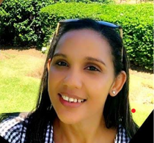

Eurinah Koeras is an experienced cell biologist with a particular passion for Andrology, focusing on the complexities of male reproductive health. Eurinah graduated with a Masters in Science degree from Stellenbosch University, and is currently finalising her PhD in the Medical Bioscience Department, where she focused her research on prostate cancer and benign prostatic hyperplasia. In addition, Mrs Koeras is also a member of the American Urological Association. Beyond research, she is deeply passionate about teaching, were she had the privilege of working with primary and secondary school students in impoverished communities. Her teaching career has since extended to tertiary level, where Eurinah has lectured students in Sport & Exercise Science, Biokinetics, Nursing, Dietetics,

Complementary Medicine, and Medical Bioscience, at both undergraduate and postgraduate level. She is actively involved in academic mentorship, currently co-supervising postgraduate students, guiding their research projects and contributing to their academic and professional development.

**Ghaleelullah Achmat: Sport, Recreation and Exercise Science**

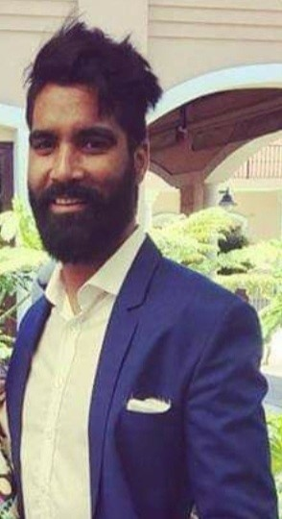

Ghaleelullah Achmat is a Lead Biokineticist. He holds the following academic qualifications: BA. SES (PSYCHOLOGY) (UWC), BA (HONS) Biokinetics (UWC) and MASTERS BIOKINETICS (UWC)

Ghaleelullah Achmat is a practice owner and lead biokineticist for the University of the Western Cape (UWC) in the Sport Recreation & Exercise Science (SRES) department. He is a researcher in the field of Exercise Science and Sports Medicine. Currently a PhD candidate with the running title "developing physical activity guidelines for firefighters experiencing coronary heart disease risk factors and multiple health risk behaviours in the City of Cape Town". My objective is mitigating the risk of CHD through physical activity and create awareness in the public health sector. Ghaleelullah is a lecturer in the SRES department teaching orthopaedics and clinical placements on the honours biokinetics program and coaching science in the undergraduate program. In addition, he has a huge interest in exercise testing, final phase sport rehabilitation, sport technology, elite-performances in sport and strength and conditioning: USA Cricket, CSA National Academy, CSA Invitational Team, WP Men’s Senior Team

WP Colts, WP Academy.

**Dr Makhaya Malema : Sport, Recreation and Exercise Science**

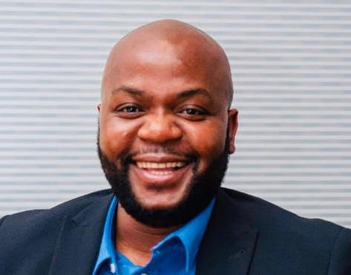

Dr. Makhaya Malema is an early career researcher in the field of Leisure and Recreation. He holds a PhD in Sports, Recreation & Exercise Science and is a Senior Lecturer at the University of the Western Cape. His current research focuses on using leisure education for leadership development among youth with physical disabilities. Dr. Makhaya Malema is involved in community recreation programmes with NGO’s from disadvantaged backgrounds and health institutions for special populations.

|  |  |
| --- | --- |
| **Theme** | After Olympics Unlock Olympic Knowledge |
| **Location** | Faculty of Education |
| **Start date** | Thursday 31st October 2024 |
| **Start time** | 09:00- 13:00 |
| **Venue** | UWC Library Atrium |
| **Registration Link** | <https://shorturl.at/t3EAT> |

(Each speaker is allowed 20 minutes to present and 10 minutes for Q&A)

|  |  |  |
| --- | --- | --- |
| **Time** | **Topic** | **Presenter** |
| **09h00 – 09h05** | Welcome and Introduction | Master of Ceremonies  Anslin Gysman (Artist) |
| **09h05 – 09h15** | Introduction | Dr. Shirlene Neerputh  Director of Library Services |
| **09h15 – 09h35** | *Keynote: The Value of Olympic Education* | Prof Marion Keim**,** UNESCO Chair and Director Olympic Studies Research Action Group, UWC |
| **09h35 – 09h55** | *Keynote Fostering Olympic Knowledge and Studies* | Ms Maria Bogner, Head of the IOC Olympic Studies Centre (OSC) in Lausanne |
| **0**9h50 – 10h10 | *Olympic World Library*  *(Online Presentation by postgrad students)* | Diego Girod |
| **10h10 – 10h20** | *Questions & Answers* | Master of Ceremonies |
| **10h20 - 10h35** | TEA |  |
| **10h35 – 10h55** | Topic | Dr. Makhaya Malema |
| **10h55 – 11h05** | Questions & Answers | Master of Ceremonies |
| **11h10 – 11h30** | Topic | Eurinah Koeras |
| **11h30 – 11h40** | Questions & Answers | Master of Ceremonies |
| **11h45 – 12:05** | Topic | Ghaleelullah Archmat |
| **12h05 – 12h15** | Questions & Answers | Master of Ceremonies |
| **12h15 – 12h25** | Closing Remarks | Shehaamah Mohamed |
| **12h25 -** | LUNCH |  |