EndNote Download and Installation Guide
Contents
1. Introduction 2
2. Download the EndNote from Google Drive 2
3. Extracting Zipped EndNote Files 4
4. Installation of EndNote 4
5. Installing Kopernio 8
5.1. Installation of Kopernio for Mozilla Firefox 8
5.2. Kopernio for Google Chrome 10
6. Setting your preferred browser as default 12

Introduction
EndNote is software used for publishing and managing bibliographies, citations and references on the Windows and Macintosh desktops.
The purpose of this guide is to assist students and staff to download and install EndNote onto Windows.

Download the EndNote from Google Drive
  - Go to gmail.com and sign in to your UWC student or staff e-mail account.

  - Go to the following link https://drive.google.com/open?id=1Cn5qMnPSb8S9wn9L5zxv2RufyaSYKQYF
(If you’re logged into a google account other than your official campus e-mail account, sign out and refer to step 2.1)

  - You will be taken to your google drive account where the EndNote download files are shared, in which you will see two folders. The Mac folder contains the EndNote installation file for Apple Mac users and the Windows folder contains the installation file for Microsoft Windows users. Double Click on the Windows folder.
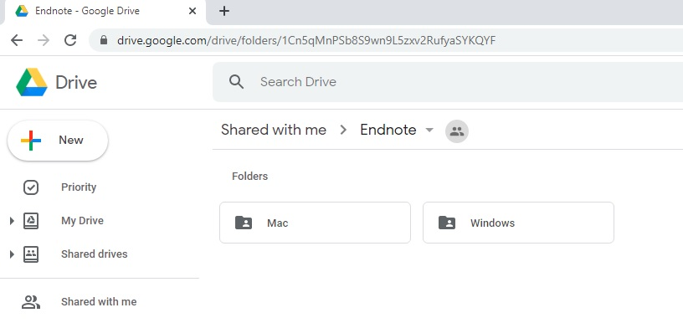
  - Within the Windows folder you will see a folder named EndNote.
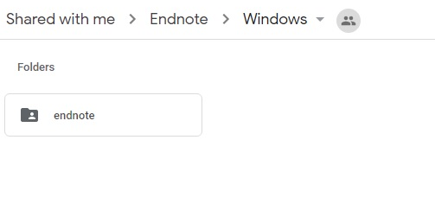
  - Right click on the EndNote Folder and select Download.
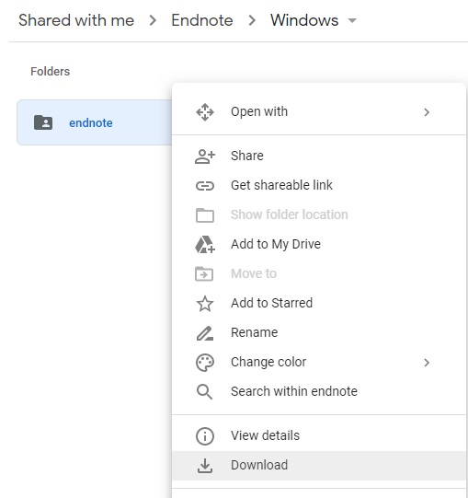

- Once the download has completed go to where your download is saved (most likely your downloads folder).
- When you download EndNote from google drive the file it is automatically compressed as a zip file. We therefore first have to extract the files before we can install EndNote. I use an application called Winrar to extract files which is why the icon for the downloaded EndNote file looks different from yours.

Extracting Zipped EndNote Files
  - Right click on the EndNote file that you’ve downloaded, then Left click on Extract Here. Your EndNote installation files will be extracted into a folder called “EndNote”.
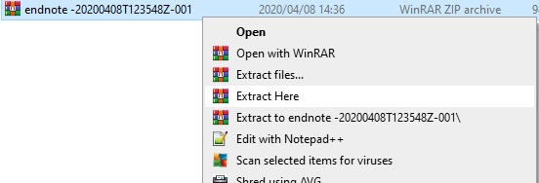

  - Double click on the EndNote folder to view the files within the folder. You will see two files in the EndNote folder, the ENX9Inst file and the License.dat file. In order for the installation to work both files should be in the same folder.

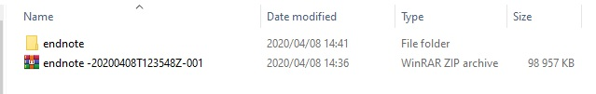

Installation of EndNote
Note: Check that Microsoft Word is not open on your device; if it is, close it before proceeding as the EndNote installation will stall otherwise

  - Double click on the ENX9Inst file, which is the EndNote installation file.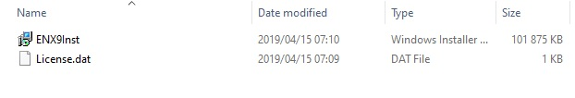
  - The EndNote installation box should appear. Click on Next.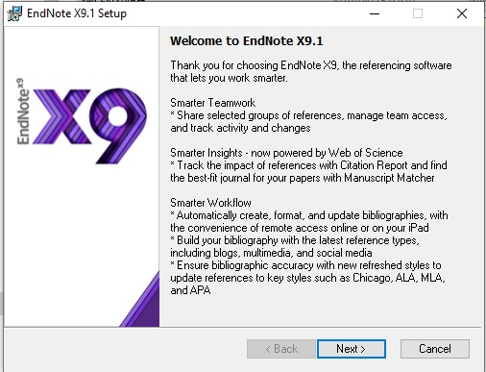

  - Select Accept in the window that displays the Volume License information.
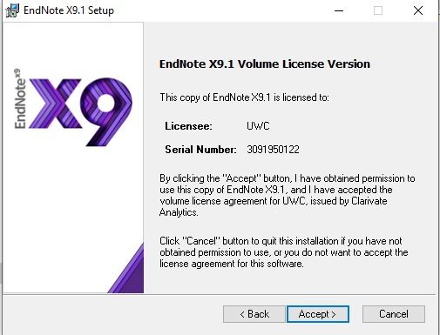

  - Select Next on the setup window that displays the Read Me Information
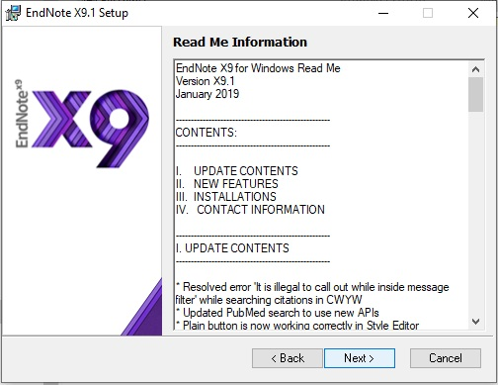

  - In the Following window Select, I accept license agreement then click Next
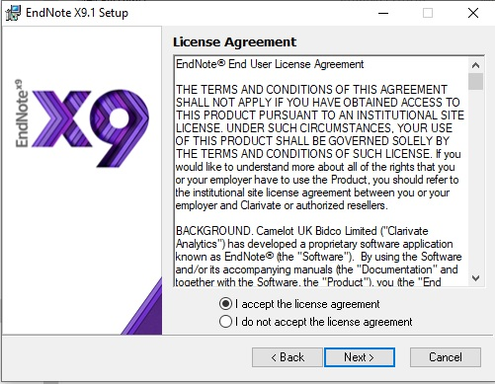

  - Under Select Installation Type make sure that Typical is selected.
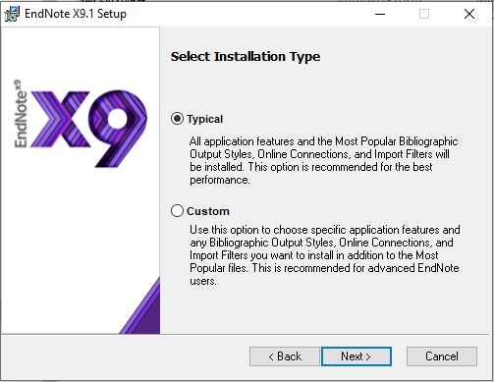

  - In the Select Destination window you can choose where you want to install EndNote. Select Next to continue.
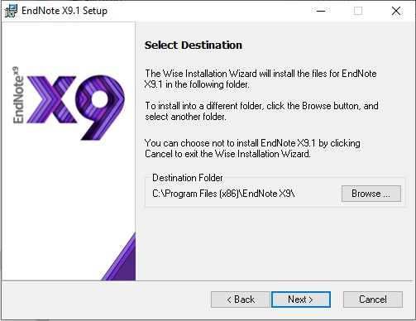

  - Select Next to complete the installations.
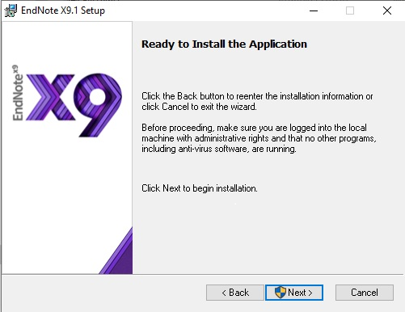

  - If a window appears asking “do you want to allow this app to make changes to your device.” Select Yes. Click Finish.

Installing Kopernio
Kopernio is a free plug-in that enables you to get pdfs into EndNote more quickly. The Kopernio extension is available for Google Chrome as well as Firefox. There is no Kopernio extension for Internet explorer.

Installation of Kopernio for Mozilla Firefox

    - Open up Mozilla Firefox and go to the following webpage, https://kopernio.com/EndNote. Click on Add to Firefox for free link on the website that you’ve opened.

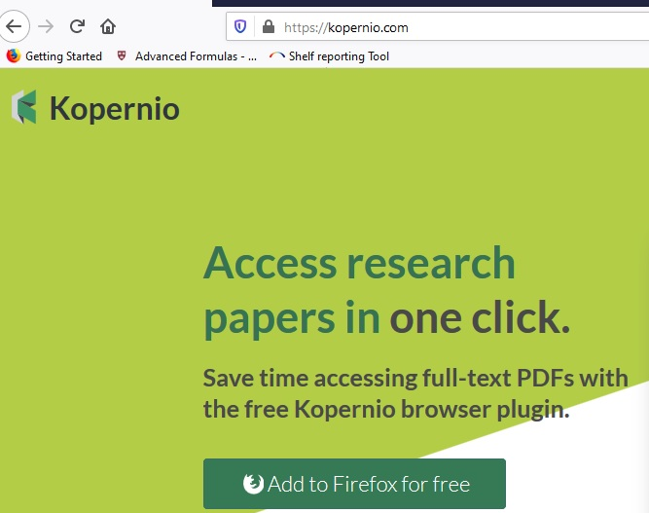

    - You will be taken to a Mozilla Firefox add in page. Select the + Add to Firefox link on the page.

    - If you wish to go ahead with the installation, Select the Add option in the permissions box that appears within the webpage.
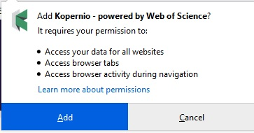

    - Select Agree and Continue to proceed with the installation

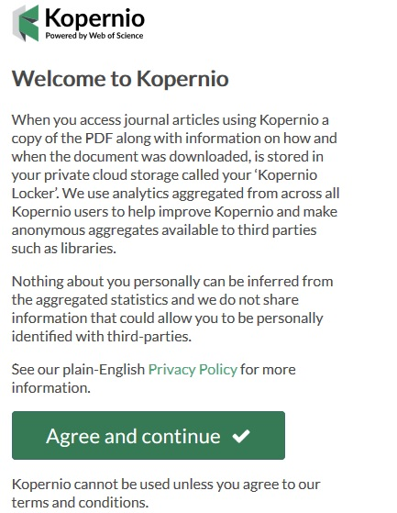

    - Insert the name of your institutions in the next webpage and then click on Select this institution

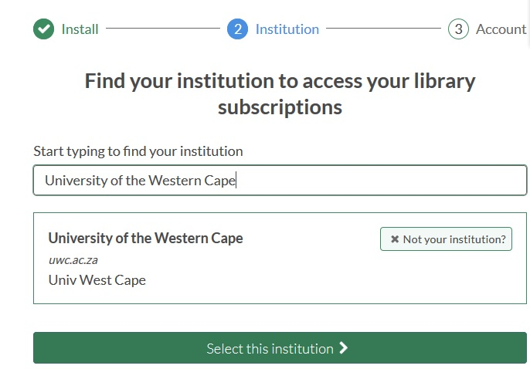

    - Create your Kopernio account in the final step of the Kopernio installation. Fill in the required information. Click on Create my Kopernio account.
Please note: The password that you will Enter here is a new password that you will be creating, that you will use to login to Kopernio. Do not use your e-mail address password.

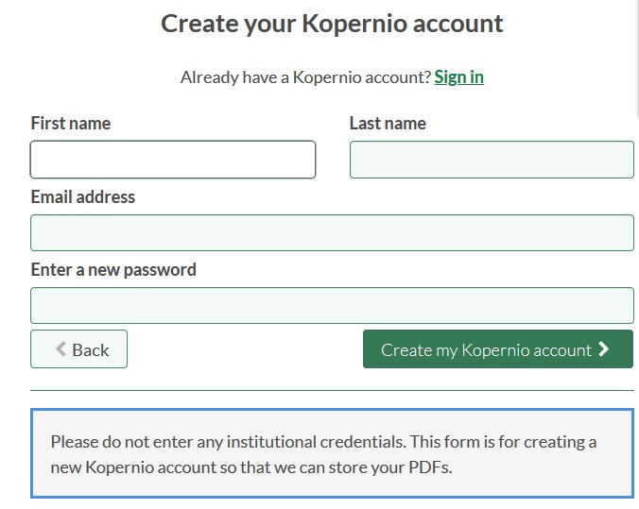

- You will receive an e-mail from Kopernio help@mg.kopernio.com asking you to verify your account. Click on the link provided in the e-mail in order to verify your account.

Kopernio for Google Chrome

    - Open up Google Chrome and go to the following webpage, https://kopernio.com/EndNote. Click on Add to Chrome for free link on the website that you’ve opened.

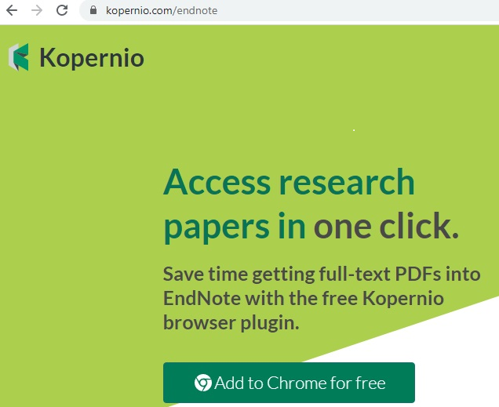

    - You will be taken to the Kopernio Extensions page in the chrome web store. Select the Add to Chrome link.

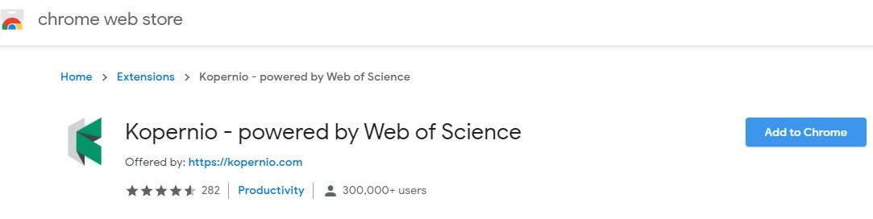
    - Select Add extension in the next pop-up window in your browser.

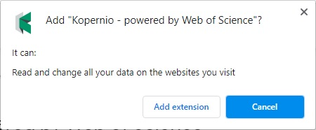

    - Insert the name of your institutions in the next webpage and then click on Select this institution

    - Create your Kopernio account in the final step of the Kopernio installation. Fill in the required information. Click on Create my Kopernio account.
Please note: The password that you will Enter here is a new password that you will be creating, that you will use to login to Kopernio. Do not use your e-mail address password.

- You will receive an e-mail from Kopernio help@mg.kopernio.com asking you to verify your account. Click on the link provided in the e-mail in order to verify your account.

Setting your preferred browser as default
If you want to change your default browser from the default Microsoft web browser you can do the following

  - Type the words Default apps into your Search Bar in Windows 10. Click on the Default apps option that has the words System settings beneath it.
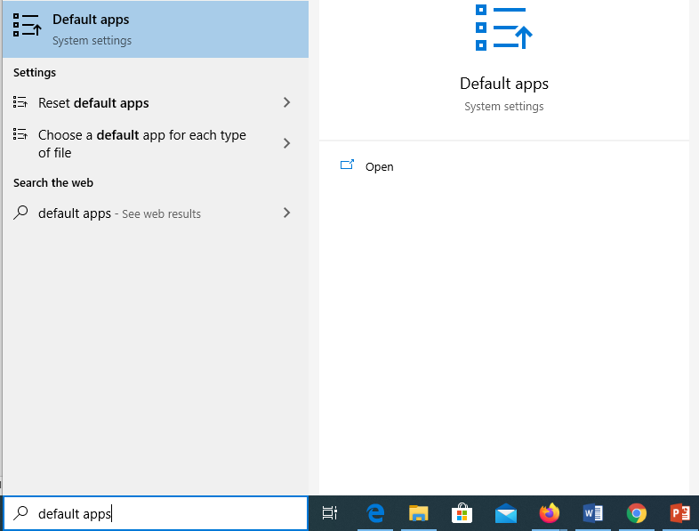

  - On the right side of the System settings screen, you will see the Default apps heading. Scroll down in the right pane until you reach the Web browser. Click on the default browser under the word Web browser, in this example it’s Microsoft Edge.

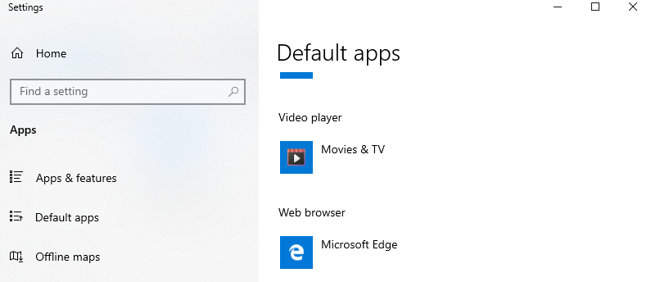

  - You will now be provided with a list of all installed Web Browsers. Click on the Web browser that you wish to use as your default browser.

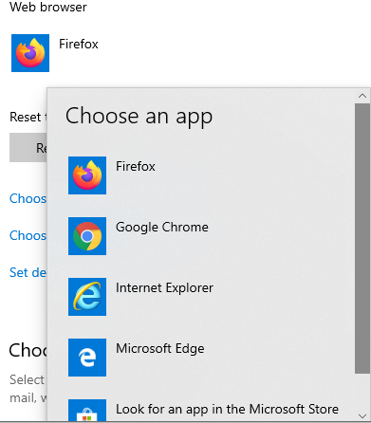

Congratulations, your EndNote application is ready for use.

