PHOTOCOPYING IN UWC LIBRARY
At the photocopier:

1.The photocopier should show the “Authentication Screen” 2.Press the “Username” button to the left of the first blank field, enter the username “testusersimple” EG. (STUDENT NUMBER) using the on-screen keyboard and press “OK”. Likewise, press the “Password” button and enter your Date of birth - Year/Month/Date. Your screen should now look like this, press “Login”.

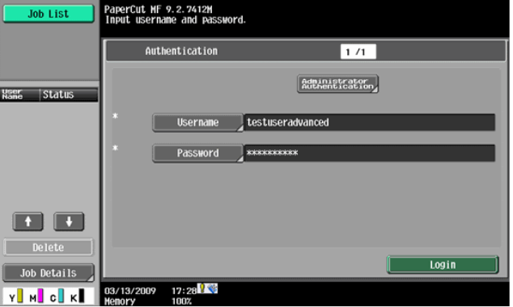
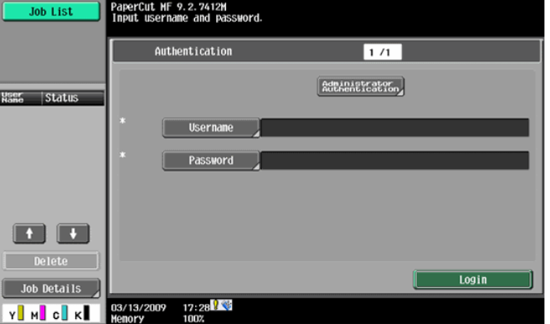

3.The screen will now show a login confirmation: 4. At this point the copier will be enabled for usage. Follow the onscreen instructions and perform some test copying, i.e. press the “Start” button on the device button panel and perform a copy as normal.
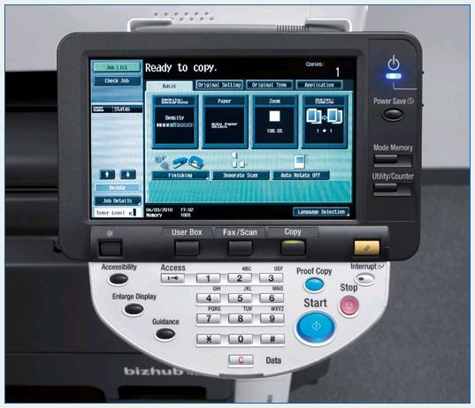
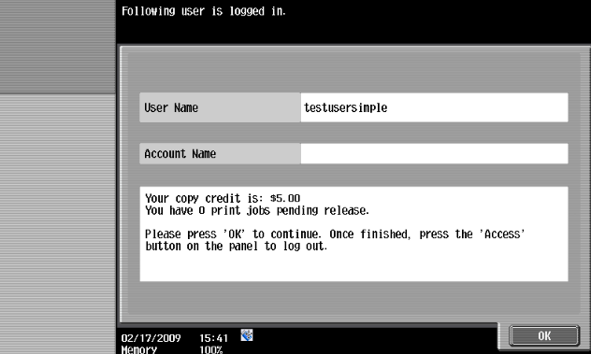

5.Once completed copying press the “Access” button on the device’s
button panel and confirm logging out by pressing “Yes” and “OK” on
the screen.
